THINGS TO CONSIDER WHEN
SELLING YOUR HOUSE

SUMMER 2018
EDITION

TABLE OF CONTENTS
3 5 Reasons To Sell This Summer

WHAT'S HAPPENING IN THE HOUSING MARKET?

- Lack Of Listings Slowing Down The Market
- Buyer Demand Continues To Outpace Inventory Of Homes For Sale
- Home Prices Over The Last Year

- The Real Reason Home Prices Are Increasing
10 675,000 Homeowners Regained Equity In 2017!

THE HOUSING MARKET FORECAST
- The 'Great News' About Rising Prices

- Where Are Interest Rates Headed?
- Don’t Wait! Move Up To The Home You've Always Wanted

WHAT TO EXPECT WHEN SELLING YOUR HOUSE

- The Role Access Plays In Getting Your House Sold!
- How To Get The Most Money From The Sale Of Your Home

PICK THE PERFECT PARTNER

- Homeowners: Your Home Must Be Sold Twice

- 5 Reasons You Shouldn’t For Sale By Owner
- The Importance Of Using An Agent When Selling Your Home

- Two Things You Don’t Need To Hear From Your Listing Agent


5 Reasons To Sell This Summer!

Here are five reasons listing your home for sale this summer makes sense.

Demand Is Strong
The latest Buyer Traffic Report from the National Association of Realtors (NAR) shows that buyer demand remains very strong throughout the vast majority of the country. These buyers are ready, willing and able to purchase…and are in the market right now! More often than not, multiple buyers are competing with each other to buy the same home.
Take advantage of the buyer activity currently in the market.

There Is Less Competition Now
Housing inventory is still under the 6-month supply that is needed for a normal housing market. This means that, in the majority of the country, there are not enough homes for sale to satisfy the number of buyers in the market. This is good news for homeowners who have gained equity as their home values have increased. However, additional inventory could be coming to the market soon.
Historically, the average number of years a homeowner stayed in his or her home was six, but that number has hovered between nine and ten years since 2011. There is a pent-up desire for many homeowners to move as they were unable to sell over the last few years because of a negative equity situation. As home values continue to appreciate, more and more homeowners will be given the freedom to move.
The choices buyers have will continue to increase. Don’t wait until this other inventory comes to market before you decide to sell.

The Process Will Be Quicker
Today’s competitive environment has forced buyers to do all they can to stand out from the crowd, including getting pre-approved for their mortgage financing. This makes the entire selling process much faster and much simpler as buyers know exactly what they can afford before home shopping. According to Ellie Mae’s latest Origination Insights Report, the average time it took to close a loan was 41 days.

There Will Never Be a Better Time to Move Up
If your next move will be into a premium or luxury home, now is the time to move up! The inventory of homes for sale at these higher price ranges has forced these markets into a buyer’s market. This means that if you are planning on selling a starter or trade-up home, your home will sell quickly AND you’ll be able to find a premium home to call your own!
Prices are projected to appreciate by 5.2% over the next year according to CoreLogic. If you are moving to a higher-priced home, it will wind up costing you more in raw dollars (both in down payment and mortgage payment) if you wait.

It’s Time to Move on With Your Life
Look at the reason you decided to sell in the first place and determine whether it is worth waiting. Is money more important than being with family? Is money more important than your health? Is money more important than having the freedom to go on with your life the way you think you should?
Only you know the answers to the questions above. You have the power to take control of the situation by putting your home on the market. Perhaps the time has come for you and your family to move on and start living the life you desire.


That is what is truly important.


Lack Of Listings Slowing Down The Market

The housing crisis is finally in the rear-view mirror as the real estate market moves down the road to a complete recovery. Home values are up, home sales are up, and distressed sales (foreclosures and short sales) have fallen to their lowest points in years. The market will continue to strengthen in 2018.
However, there is one thing that may cause the industry to tap the brakes: a lack of housing inventory. Buyer demand naturally increases during the summer months, but supply is not keeping up.
Here are the thoughts of a few industry experts on the subject:
Lawrence Yun, Chief Economist at National Association of Realtors
“The worsening inventory crunch through the first three months of the year inflicted even more upward pressure on home prices in a majority of markets. Following the same trend over the last couple of years, a strengthening job market and income gains are not being met by meaningful sales gains because of unrelenting supply and affordability headwinds.”
Sam Khater, Chief Economist for Freddie Mac

“As we head into late spring, the demand for purchase credit remains rock solid, which should set us up for another robust summer home sales season. While this year’s high rates – up 50 basic points from a year ago – have put pressure on the budgets of some home shoppers, weak inventory levels are what’s keeping the housing market from a stronger sales pace.”
Javier Vivas, Director of Economic Research for Realtor.com

“The dynamics of increased competition and buyer frustration are unlikely to change…. In fact, the direction of the trend is pointing to a growing mismatch between the pool of prospective buyers and existing inventory.”
Bottom Line
If you are thinking of selling, now may be the time. Demand for your house will be strong at a time when there is very little competition. That could lead to a quick sale for a really good price.

Buyer Demand Continues to Outpace Inventory of Homes For Sale

The price of any item is determined by the supply of that item, as well as the market demand. The National Association of Realtors (NAR) surveys “over 50,000 real estate practitioners about their expectations for home sales, prices and market conditions” for their Realtors Confidence Index.
Their latest edition sheds some light on the relationship between Seller Traffic (supply) and Buyer Traffic (demand).

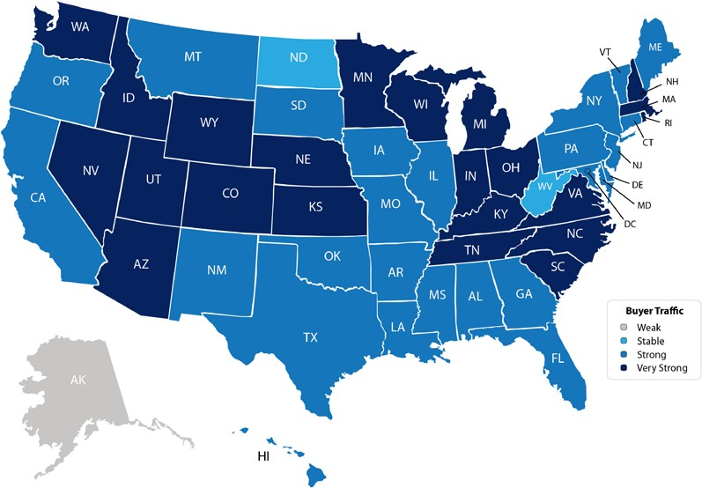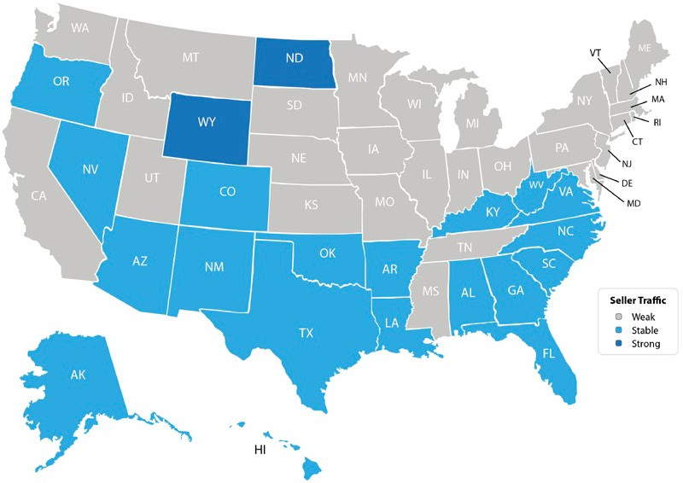Buyer Demand
The map on the right was created after asking the question:

“How would you rate buyer traffic in your area?”
The darker the blue, the more buyers there are looking for homes in that area. Only one state came in with a weak demand level.

Seller Supply
The index also asked:

“How would you rate seller traffic in your area?”
As you can see from the map on the left, the majority of the country has weak seller traffic, meaning there are far fewer homes on the market than what is needed to satisfy the buyers who are out looking for their dream homes.

Bottom Line
Looking at the maps above, it is not hard to see why prices are appreciating in many areas of the country. Until the supply of homes for sale starts to meet the buyer demand, prices will continue to increase.

Home Prices Over The Last Year

Every quarter, the Federal Housing Finance Agency (FHFA) reports on the year-over-year changes in home prices. Below, you will see that prices are up year-over-year in every region.

PACIFIC
9.53%

Year-over-Year Prices Regionally
WEST NORTH

NEW ENGLAND

5.41%

MOUNTAIN
9.42%
CENTRAL
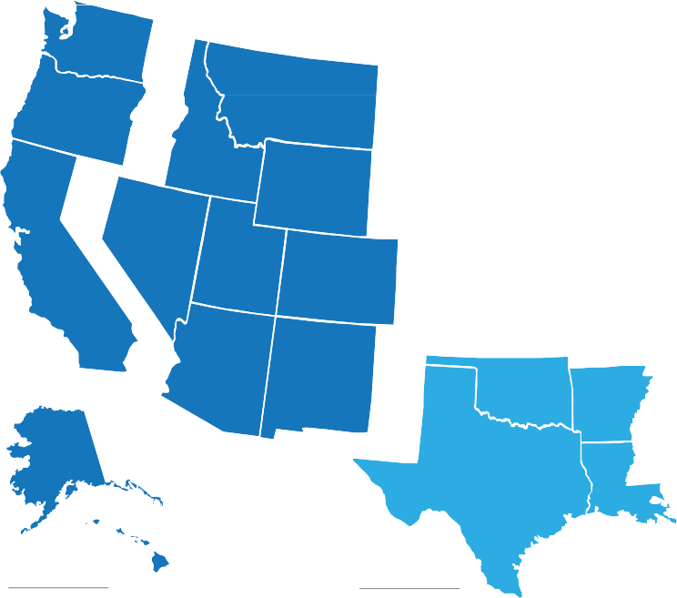5.73%
EAST NORTH CENTRAL
6.32%

MIDDLE ATLANTIC
5.60%

USA Average
6.89%

WEST SOUTH CENTRAL
5.91%

EAST SOUTH CENTRAL
5.33%

SOUTH ATLANTIC
7.20%

Looking at the breakdown by state, you can see that each state is appreciating at a different rate. This is important to know if you are planning on relocating to a different area of the country. Waiting to move may end up costing you more!

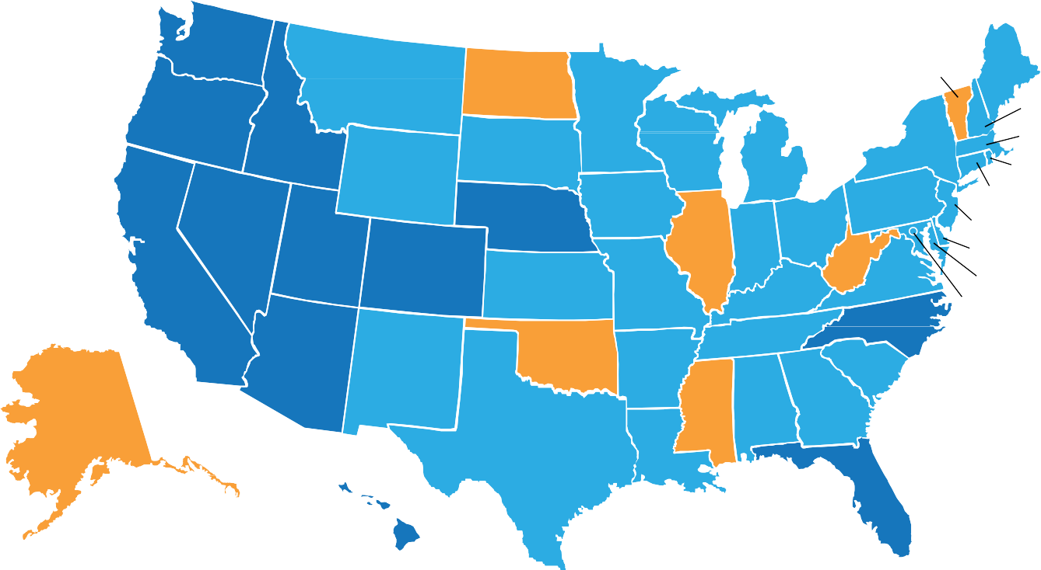Year-over-Year Prices By State

13.1%
WA

9.6%
OR

11.1%

6.1%
MT

2.3%
ND

3.1%

6.1%
MN

6.6%

VT (2.6%)

6.2%

5.3%
ME

NH (4.6%)
MA (6.9%)

ID

13.7%
3.2%
WY
SD

8.3%
WI

4.3%
IA
7.8%
MI

7.3%
NY

5.2%
PA
RI (7.0%)
CT (3.6%)
NJ (5.2%)

NV 9.9%
NE 2.8%
7.5% OH

DE (7.7%)

8.9%
CA
UT 10.6%
CO

5.8%
KS

6.1%
MO
IL IN

6.3%
KY
0.9%
WV

5.2%
VA
8.4%

MD (5.0%)
DC (7.1%)

9.5%
AZ

3.0%
NM
1.5%
OK

3.7%
AR
  - % TN NC
7.4%
SC

2.7%
2.2%
3.4%
7.7%

AK

9.2%
HI

7.4%
TX

3.6%
LA
MS AL GA

8.4%
FL
< 0.0%
0.0% to 2.9%
3.0% to 7.9%
> 8%


The Real Reason Home Prices Are Increasing

There are many unsubstantiated theories as to why home values are continuing to increase. From those who are worried that lending standards are again becoming too lenient (data shows this is untrue), to those who are concerned that prices are again approaching boom peaks because of “irrational exuberance” (this is also untrue as prices are not at peak levels when they are adjusted for inflation), there seems to be no shortage of opinion.

However, the increase in prices is easily explained by the theory of supply & demand. Whenever there is a limited supply of an item that is in high demand, prices increase.

It is that simple. In real estate, it takes a six-month supply of existing salable inventory to maintain pricing stability. In most housing markets, anything less than six months will cause home values to appreciate and anything more than seven months will cause prices to depreciate (see chart 1).
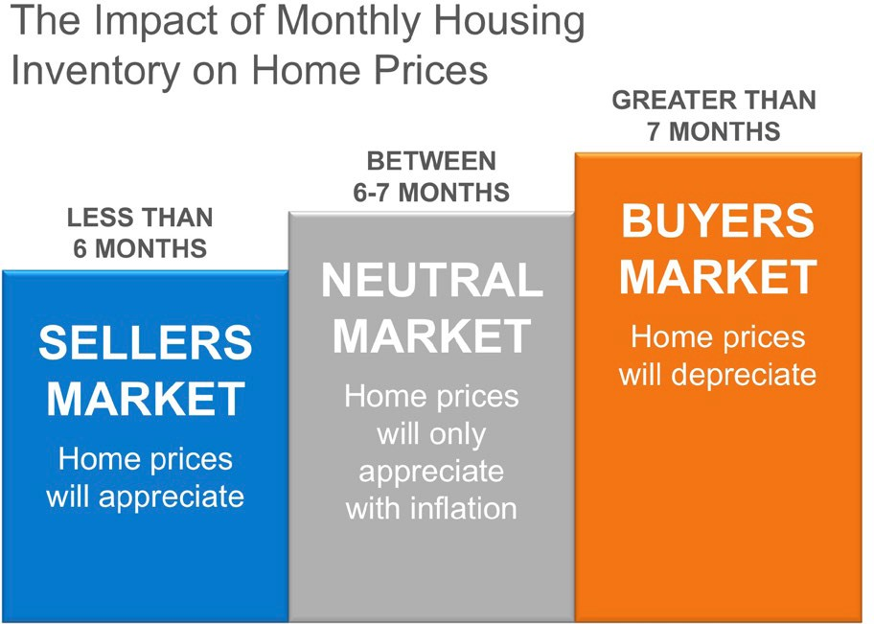

According to the Existing Home Sales Report from the National Association of Realtors (NAR), the monthly inventory of homes has been below six months for the last five years (see chart 2).
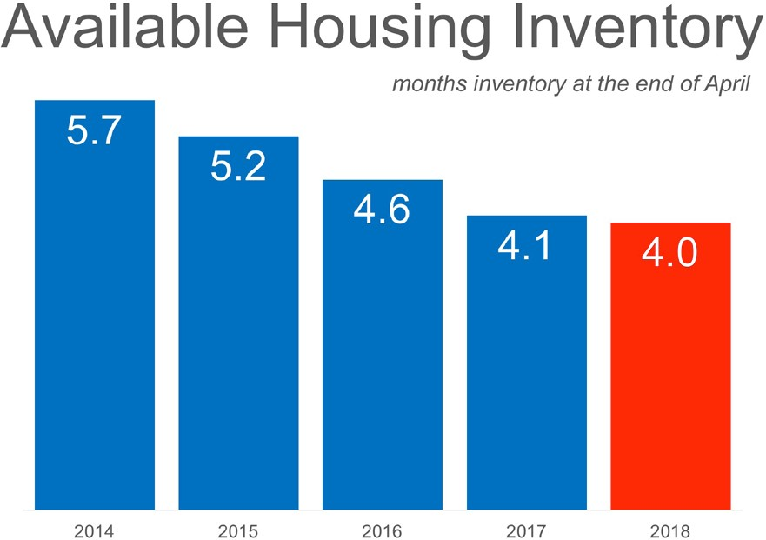

Bottom Line


If buyer demand outpaces the current supply of existing homes for sale, prices will continue to appreciate. Nothing nefarious is taking place. It is simply the theory of supply & demand working as it should.

CoreLogic’s latest Equity Report revealed that "over the past 12 months, 675,000 borrowers moved into positive equity." This is great news, as the share of homeowners with negative equity (those who owe more than their home is worth), has dropped more than 20% since the peak in Q4 of 2009 (26%) to 4.9% today.
The report also revealed:
    - The average homeowner gained approximately $15,000 in equity during the past year.
- Compared to Q4 2017, negative equity decreased 21% from 3.2 million homes, or 6.3 percent of all mortgaged properties.
- U.S. homeowners with mortgages (roughly 63 percent of all homeowners) have seen their equity increase by a total of $908.4 billion since Q4 2016, an increase of 12.2%, year-over-year.
The map below shows the percentage of homes by state with a mortgage and positive equity. (The states in gray have insufficient data to report.)

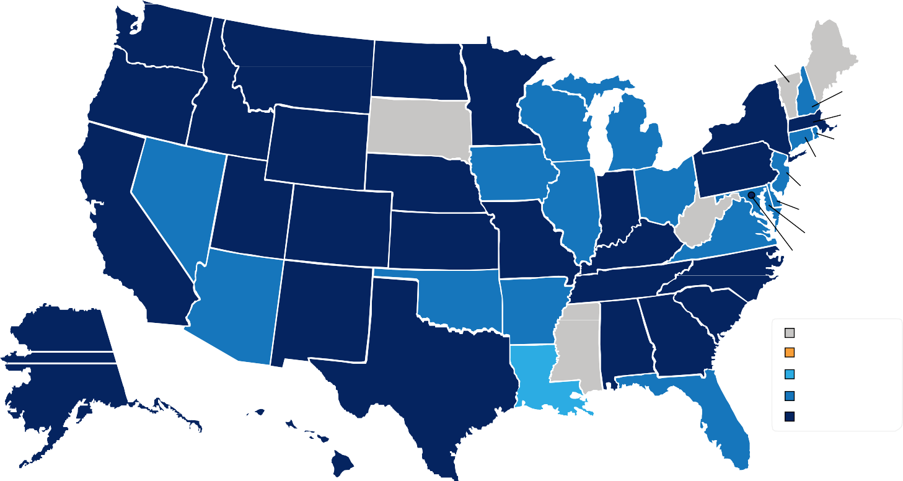
98.4%
WA

98.3%
OR

97.6%
ID

97.8%
MT

96.9%

96.2%
ND

SD

96.6%
MN

94.1%
WI

93.6%

VT

95.9%
NY

ME

NH (94.8%)
MA (95.7%)
RI (92.8%)

92.0%
NV

98.5%
WY

98.3%

95.3%
NE
94.4%
IA
MI

91.1% 97.5%
IL IN

93.2%
OH
WV
96.0%
PA
CT (91.5%)
NJ (92.1%)
DE (93.7%)

97.0%
CA
UT CO 96.8%
KS
95.8%
MO
95.6%
KY
94.7%
VA
96.3%
MD (92.4%)
DC (96.4%)

93.3%
AZ

95.7%
NM
94.9%
OK

94.4%
AR
96.3% TN NC
95.7%
SC

98.1% 95.5%
Insufficient Data

95.1%
AK

98.5%
TX

89.6%
LA
MS AL GA

91.5%
80.0% to 84.9%
85.0% to 89.9%
90.0% to 94.9%
≥ 95%

98.2%
675,000 Homeowners Regained Equity In 2017!
HI
UNITED STATES ^{FL}
95.1%

Significant Equity Is on The Rise
Frank Nothaft, Chief Economist at CoreLogic, believes this is great news for the “housing market.” He went on to say:
“The average growth in home equity was more than $15,000 during 2017, the most in four years. Because wealth gains spur additional consumer purchases, the rise in home-equity wealth during 2017 should add more than $50 billion to U.S. consumption spending over the next two to three years.”
Of the 95.1% of homeowners with positive equity in the U.S., 82.5% have significant equity (defined as more than 20%). This means that more than three out of four homeowners with a mortgage could use the equity in their current home to purchase a new home now.
The map below shows the percentage of homes by state with a mortgage and significant equity.

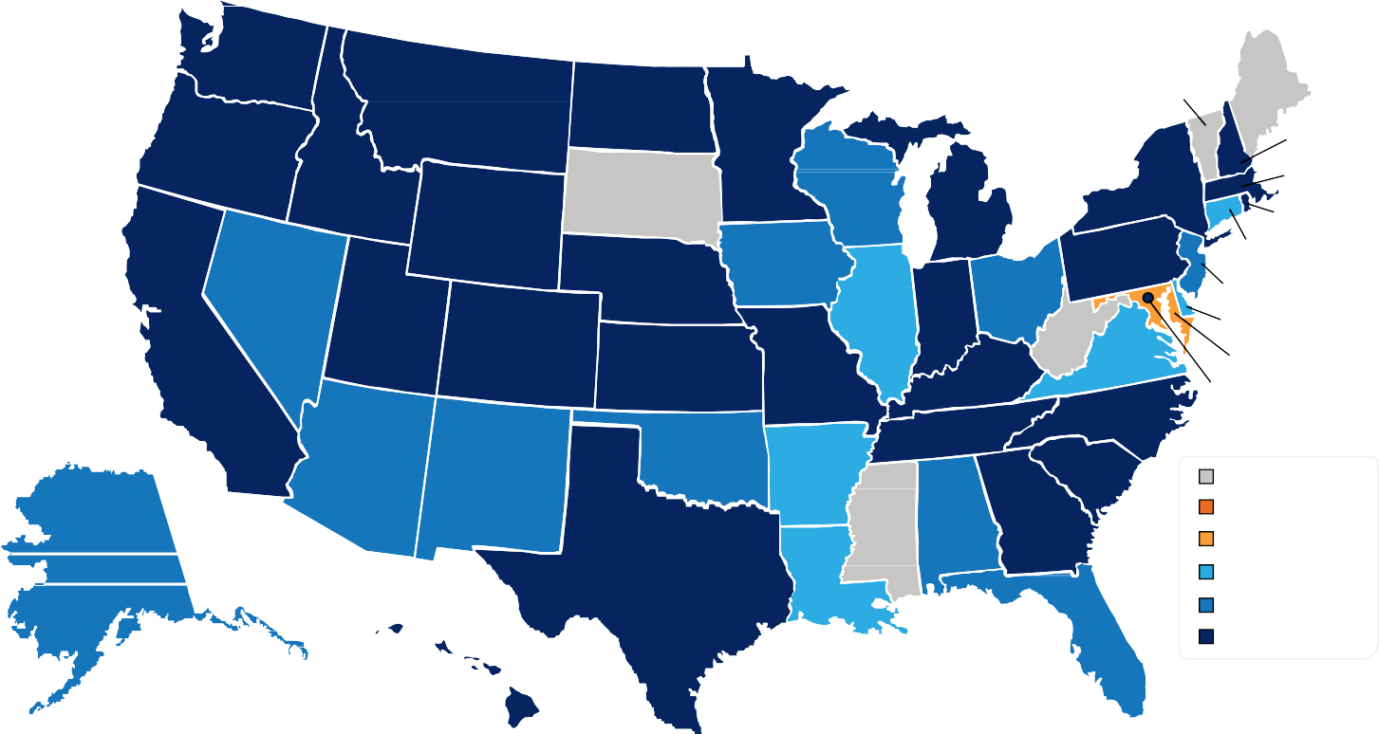
91.4%
WA

90.4%
OR

89.3%
ID

89.4%
MT

81.6%

86.1%
ND

SD

83.8%
MN

79.2%
WI

81.8%

VT

87.2%
NY

ME

NH (80.2%)
MA (86.4%)
RI (80.3%)

77.3%
NV

90.3%
WY

89.4%

82.4%
NE
78.5%
IA
MI

73.1% 88.1%
IL IN

78.6%
OH
WV
82.7%
PA
CT (73.3%)
NJ (75.9%)
DE (74.2%)

88.7%
CA
UT CO 87.6%
KS
82.1%
MO
81.7%
KY
72.0%
VA
82.7%
MD (69.8%)
DC (84.1%)

75.8%
AZ

77.9%
NM
76.0%
OK

72.2%
AR
  - % TN NC
81.3%
SC

Insufficient Data

77.3% 81.7%
< 64.9%

76.6%
AK

92.1%
TX

72.0%
LA
MS AL GA

77.4%
65.0% to 69.9%
70.0% to 74.9%
75% to 79.9%
80.0% >

Bottom Line
91.0%
HI
UNITED STATES ^{FL}
82.5%


If you are one of the many homeowners who is unsure of how much equity you have in your home and are curious about your ability to move, let’s meet up to evaluate your situation.

The 'Great News' About Rising Prices

Recently there has been a lot of talk about home prices and if they are accelerating too quickly. In some areas of the country, seller supply (homes for sale) cannot keep up with the number of buyers out looking for a home, which has caused prices to rise.
The great news about rising prices, however, is that according to CoreLogic’s latest US Economic Outlook, the average American household gained over $15,000 in equity over the course of the last year, largely due to home value increases.
The map below was created from CoreLogic’s report and shows the average equity gain per mortgaged home over the past year.
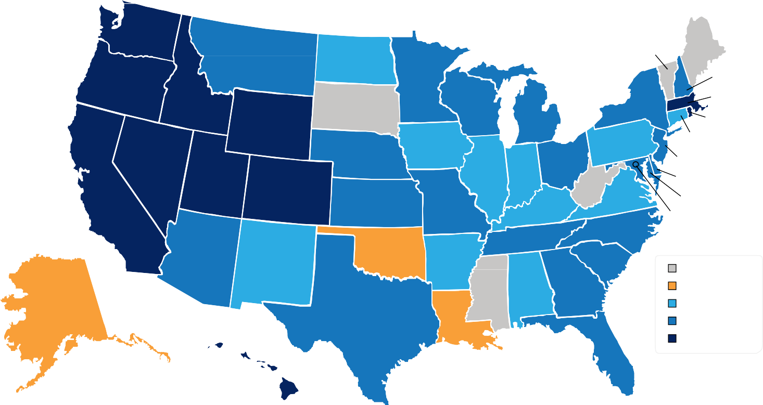
$40K
WA
$11K
MT
$7K
ND
VT
ME
$17K
OR
$21K
ID
$12K
MN
$16K
WY
SD
$9K
WI
$8K
NY
$27K
NV
$6K
IA
$11K
MI
$7K
PA
$44K
CA
$27K
UT
$8K
NE
$21K
CO
$7K
IL
$7K
IN
$10K
OH
$9K
KS
WV
$8K
MO
$6K
KY
$7K
VA
$10K
NC
NH ($13K) MA ($23K) RI ($20K)
CT ($4K) NJ ($12K) DE ($8K) MD ($11K)
DC ($10K)
$13K
AZ
$5K
NM
$2K
OK
$11K TN
$5K
AR
$8K
SC
$3K
AK
MS
$4K $11K
AL GA
$9K
TX
$0K
LA
Insufficient Data
≤ $3K
$4K to $7K
$8K to $14K
≥ $15K
$18K
HI
UNITED STATES
$15K
$12K
FL
For those who are worried that we are doomed to repeat 2006 all over again, it is important to note that homeowners are investing their new found equity in their homes and themselves, not in depreciating assets.
The added equity is helping families put their children through college, and even invest in starting small businesses, allowing them to pay off their mortgage sooner or move up to the home that will better suit their needs now.
Bottom Line
CoreLogic predicts that home prices will appreciate by another 5.2% by this time next year. If you are a homeowner looking to take advantage of your home equity by moving up to your dream home, let's discuss your options!


Where Are Interest Rates Headed?

The interest rate you pay on your home mortgage has a direct impact on your monthly payment. The higher the rate, the greater the payment will be. That is why it is important to know where rates are headed when deciding to start your home search.
Below is a chart created using Freddie Mac’s U.S. Economic & Housing Marketing Outlook. As you can see, interest rates are projected to increase steadily over the course of the next 12 months.
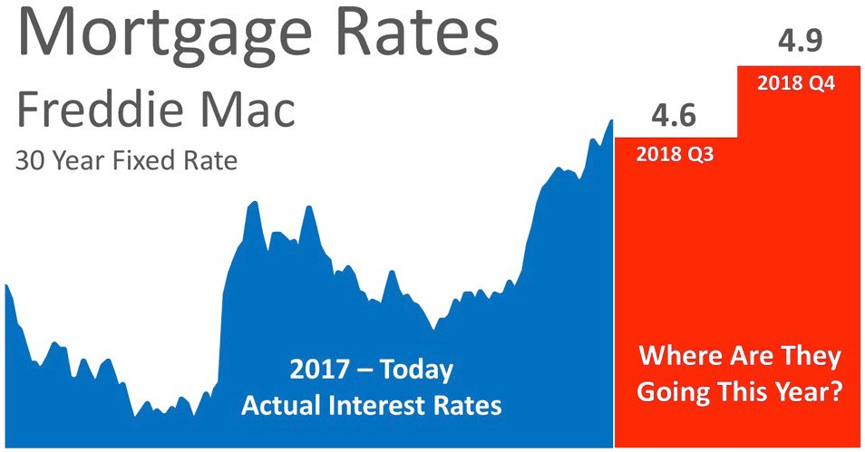

How Will This Impact Your Mortgage Payment?
Depending on the amount of the loan that you secure, a half of a percent (.5%) increase in interest rate can increase your monthly mortgage payment significantly.
According to CoreLogic’s latest Home Price Index, national home prices have appreciated 7.0% from this time last year and are predicted to be 5.2% higher next year.
If both the predictions of home price and interest rate increases become reality, families would wind up paying considerably more for their next home.

Bottom Line
Even a small increase in interest rate can impact your family’s wealth. Let’s get together to evaluate your ability to purchase your dream home.


Don’t Wait! Move Up To Your Dream Home

According to Freddie Mac’s Primary Mortgage Market Survey, interest rates for a 30-year fixed rate mortgage have increased by half of a percentage point, to around 4.5%, in 2018. This is still significantly lower than recent history.
The interest rate you secure when buying a home not only greatly impacts your monthly housing costs, but also impacts your purchasing power.
Purchasing power, simply put, is the amount of home you can afford to buy for the budget you have available to spend. As rates increase, the price of the house you can afford will decrease if you plan to stay within a certain monthly housing budget.
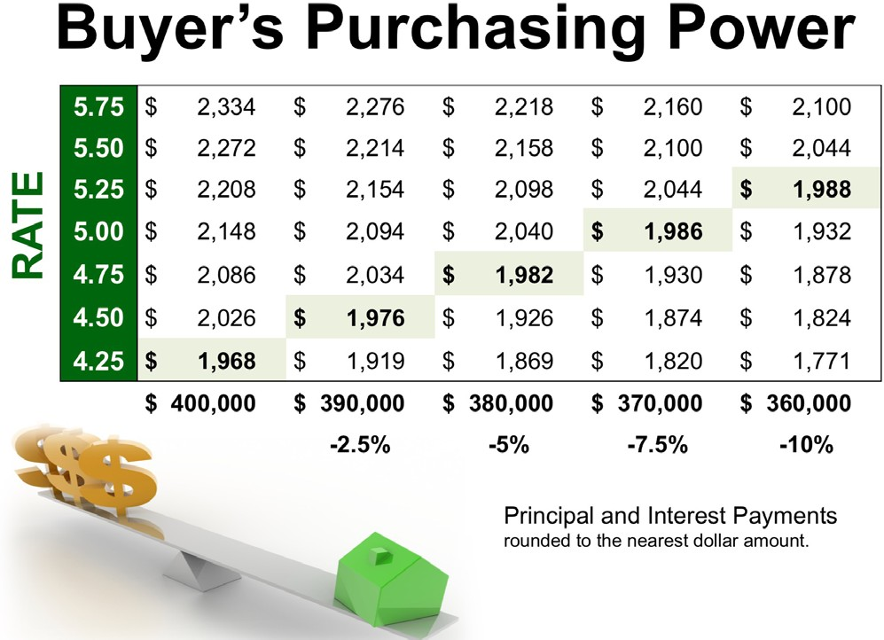
The chart to the right shows the impact rising interest rates would have if you planned to purchase a home within the national median price range, and planned to keep your principal
and interest payments under $2,000 a month.
With each quarter of a percent increase in
interest rate, the value of the home you can afford decreases by 2.5% (in this example,
$10,000). Experts predict that mortgage rates will be over 5% by this time next year.
Act now to get the most house for your hard-earned money.


The Role Access Plays In Getting Your House Sold!

So you’ve decided to sell your house. You’ve hired a real estate professional to help you with the entire process and they have asked you what level of access you want to provide to potential buyers.
There are four elements to a quality listing. At the top of the list is Access, followed by Condition, Financing and Price. There are many levels of access that you could provide to your agent to be able to show your home.
Here are five levels of access that you could provide to a buyer with a brief description:
    - Lockbox on the Door – This allows buyers the ability to see the home as soon as they are aware of the listing, or at their convenience.
    - Providing a Key to the Home – Although the buyer’s agent may need to stop by an office to pick up the key, there is little delay in being able to show the home.
    - Open Access with a Phone Call – The seller allows showing with just a phone call’s notice.
    - By Appointment Only (example: 48 Hour Notice) – Many out-of-town/state buyers and relocation buyers visit an area they would like to move to and only have the weekend to view homes. They may not be able to plan that far in advance, or may be unable to wait the 48 hours to be shown the house.
    - Limited Access (example: the home is only available on Mondays or Tuesdays at 2 pm or for only a couple of hours a day) – This is the most difficult way to be able to show your house to potential buyers.
In a competitive marketplace, access can make or break your ability to get the price you are looking for, or even sell your house at all.


How To Get The Most Money
From The Sale Of Your Home

Every homeowner wants to make sure they maximize their financial reward when selling their home. But how do you guarantee that you receive maximum value for your house? Here are two keys to ensure that you get the highest price possible.

Price it a LITTLE LOW
This may seem counterintuitive. However, let’s look at this concept for a moment. Many homeowners think that pricing their home a little OVER market value will leave them room for negotiation. In actuality, this just dramatically lessens the demand for your house (see chart below).

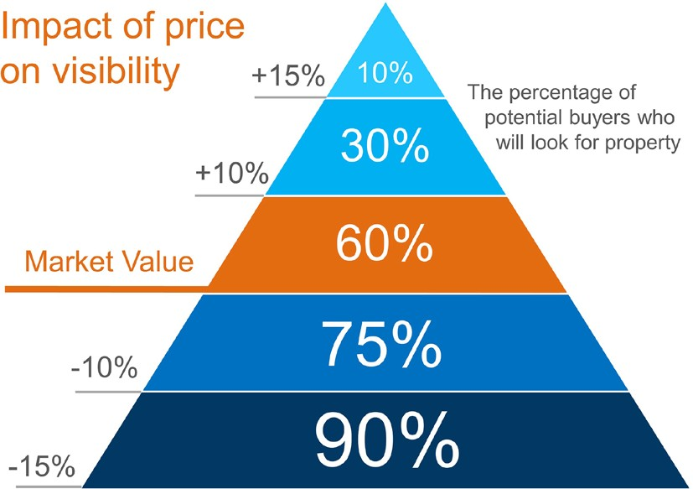

Instead of the seller trying to ‘win’ the negotiation with one buyer, they should price it so that demand for the home is maximized. In doing this, the seller will not be fighting with a buyer over the price, but instead will have multiple buyers fighting with each other over the house.
Realtor.com gave this advice:
“Aim to price your property at or just slightly below the going rate. Today’s buyers are highly informed, so if they sense they’re getting a deal, they’re likely to bid up a property that’s slightly underpriced, especially in areas with low inventory.”

Use a Real Estate Professional
This, too, may seem counterintuitive. The seller may think they would make more money if they didn’t have to pay a real estate commission. With this being said, studies have shown that homes typically sell for more money when handled by a real estate professional.
A study by Collateral Analytics reveals that FSBOs don’t actually save any money, and in some cases may be costing themselves more, by not listing with an agent.
In the study, they analyzed home sales in a variety of markets in 2016 and the first half of 2017. The data showed that:
“FSBOs tend to sell for lower prices than comparable home sales, and in many cases below the average differential represented by the prevailing commission rate.”
The results of the study showed that the differential in selling prices for FSBOs when compared to MLS sales of similar properties is about 5.5%. Sales in 2017 suggest the average price was near 6% lower for FSBO sales of similar properties.

Bottom Line
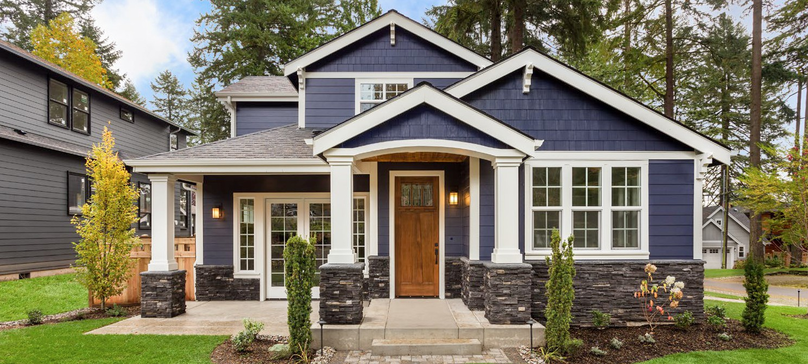
Price your house at or slightly below the current market value and hire a professional. That will guarantee you maximize the price you get for your house.

Homeowners: Your Home Must Be Sold Twice

In today’s housing market, where supply is very low and demand is very high, home values are increasing rapidly. Many experts are projecting that home values could appreciate by another 5%+ over the next twelve months. One major challenge in such a market is the bank appraisal.
If prices are surging, it is difficult for appraisers to find adequate, comparable sales (similar houses in the neighborhood that recently closed) to defend the selling price when performing the appraisal for the bank.
Every month in their Home Price Perception Index (HPPI), Quicken Loans measures the disparity between what a homeowner who is seeking to refinance their home believes their house is worth, and an appraiser’s evaluation of that same home.
Bill Banfield, Executive VP of Capital Markets at Quicken Loans, urges anyone looking to buy or sell in today’s market to remember the impact of this challenge:
“The appraisal is one of the most important pieces of data in the mortgage process. Often the entire transaction hinges on the appraisal showing a number similar to what the homeowner estimated at the beginning of the process.
If the appraisal is lower it could mean the homeowner needs to bring additional cash to close, or the loan may need to be reworked. It’s very promising to see the homeowner estimate and the appraiser opinion so close together.”
The chart below illustrates the changes in home price estimates over the last 12 months.

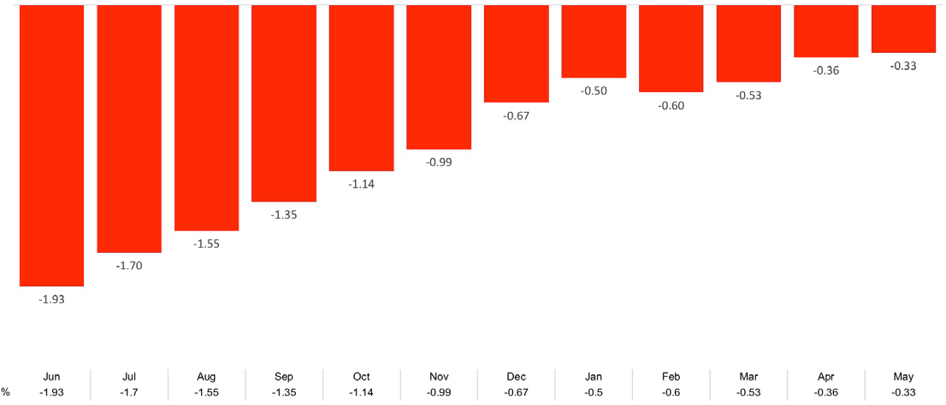
Appraiser Home Value Opinions Compared to Homeowner Estimates

Bottom Line
Every house on the market has to be sold twice; once to a prospective buyer and then to the bank (through the bank’s appraisal). With escalating prices, the second sale might be even more difficult than the first. If you are planning on entering the housing market this year, let’s get together to discuss this and any other obstacle that may arise.


5 Reasons You Shouldn’t For Sale By Owner

In today’s market, with home prices rising and a lack of inventory, some homeowners may consider trying to sell their home on their own, known in the industry as a For Sale By Owner (FSBO). There are several reasons why this might not be a good idea for the vast majority of sellers.
Here are the top five reasons:
- Exposure to Prospective Purchasers
Recent studies have shown that 95% of buyers search online for a home. That is in comparison to only 15% looking at print newspaper ads. Most real estate agents have an internet strategy to promote the sale of your home. Do you?
- Results Come from the Internet
Where did buyers find the home they actually purchased?
  - 49% on the internet • 7% from a yard sign
  - 31% from a Real Estate Agent • 1% from newspapers
The days of selling your house by just putting up a sign and putting it in the paper are long gone. Having a strong internet strategy is crucial.
- There Are Too Many People to Negotiate With
Here is a list of some of the people with whom you must be prepared to negotiate if you decide to For Sale By Owner:
  - The buyer who wants the best deal possible
  - The buyer’s agent who solely represents the best interest of the buyer
  - The buyer’s attorney (in some parts of the country)
  - The home inspection companies, which work for the buyer and will almost always find some problems with the house
  - The appraiser if there is a question of value

- FSBOing Has Become More and More Difficult
The paperwork involved in selling and buying a home has increased dramatically as industry disclosures and regulations have become mandatory. This is one of the reasons that the percentage of people FSBOing has dropped from 19% to 8% over the last 20+ years.
- You Net More Money When Using an Agent
Many homeowners believe that they will save the real estate commission by selling on their own. Realize that the main reason buyers look at FSBOs is because they also believe they can save the real estate agent’s commission. The seller and buyer can’t both save the commission.
A study by Collateral Analytics revealed that FSBOs don’t actually save anything, and in some cases, may be costing themselves more, by not listing with an agent. One of the main reasons for the price difference at the time of sale is:
“Properties listed with a broker that is a member of the local MLS will be listed online with all other participating broker websites, marketing the home to a much larger buyer population. And those MLS properties generally offer compensation to agents who represent buyers, incentivizing them to show and sell the property and again potentially enlarging the buyer pool.”
If more buyers see a home, the greater the chances are that there could be a bidding war for the property. The study showed that the difference in price between comparable homes of size and location is currently at an average of 6%.
Why would you choose to list on your own and manage the entire transaction when you can hire an agent and not have to pay anything more?
Bottom Line

Before you decide to take on the challenges of selling your house on your own, let’s get together and discuss your needs.



The Importance Of Using An Agent When Selling Your Home

When a homeowner decides to sell their house, they obviously want the best possible price with the least amount of hassles. However, for the vast majority of sellers, the most important result is to actually get the home sold.
In order to accomplish all three goals, a seller should realize the importance of using a real estate professional. We realize that technology has changed the purchaser’s behavior during the home buying process. According to the National Association of Realtors’ latest Profile of Home Buyers & Sellers, the percentage of buyers who used the internet in their home search increased to 95%.
However, the report also revealed that 95% of buyers that used the internet when searching for a home purchased their home through either a real estate agent/broker or from a builder or builder’s agent. Only 2% purchased their home directly from a seller whom the buyer didn’t know.
Buyers search for a home online, but then depend on an agent to find the home they will buy (52%), to negotiate the terms of the sale (47%) and price (38%), or to help understand the process (60%).
The plethora of information now available has resulted in an increase in the percentage of buyers that reach out to real estate professionals to “connect the dots.” This is obvious as the percentage of overall buyers who used an agent to buy their home has steadily increased from 69% in 2001.

Bottom Line
If you are thinking of selling your home, don’t underestimate the role that a real estate professional can play in the process.


Two Things You Don’t Need To Hear From Your Listing Agent

You’ve decided to sell your house. You begin to interview potential real estate agents to help you through the process. You need someone you trust enough to:

Set the market value on possibly the largest asset your family owns (your home)
    - Set the time schedule for the successful liquidation of that asset
    - Set the fee for the services required to liquidate that asset
An agent must be concerned first and foremost with you and your family in order to garner that degree of trust. Make sure this is the case.
Be careful if the agent you are interviewing begins the interview by:

Bragging about their success
    - Bragging about their company’s success
An agent’s success and the success of their company can be important considerations when deciding on the right real estate professional to represent you in the sale of your house. However, you first need to know that they care about what you need and what you expect from the sale. If the agent is not interested in first establishing your needs, how successful they may seem is much
less important.
Look for someone with the ‘heart of a teacher’ who comes in prepared to explain the current real estate market to you, and is patient enough to take the time to show you how it may impact the sale of your home; not someone only interested in trying to sell you on how great they are.

You have many agents from which to choose. Pick someone who truly cares.

CONTACT ME TO TALK MORE
I'm sure you have questions and concerns...

I would love to talk with you more about what you read here, and help you on the path to selling your house. My contact information is below. I look forward to hearing from you...

LARRY SMYTH
Farrell Smyth, Inc San Luis Obispo, CA larry@farrellsmyth.com www.farrellsmyth.com
(805) 543-2172

